Frozen Raspberry Layer Cake
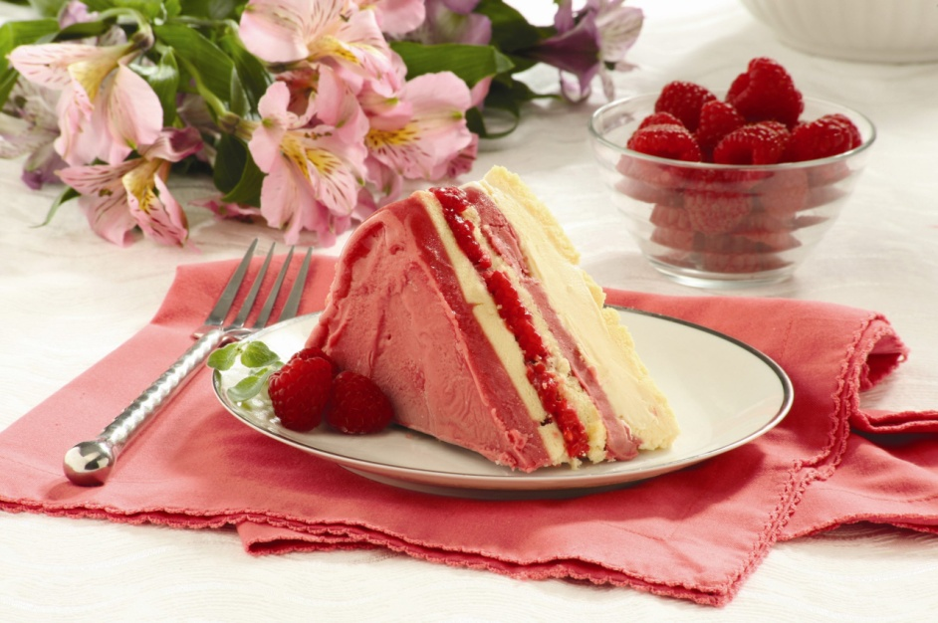
DESCRIPTION:
This colorful and light cake will fool friends and family into believing that great effort went into making this dessert. No need to let on that it comes together easily with store-bought raspberry sorbet, vanilla ice cream, frozen pound cake, and fresh raspberries.

INGREDIENTS:
1/4 c. cold sour cream
1/2 c. confectioners’ sugar
1 c. cold heavy cream
1/4 c. pistachios, chopped
2 pt. raspberries, divided
1 tbsp. fresh lemon juice
1 tbsp. pure honey
2 tbsp. fresh mint leaves

INSTRUCTIONS:
Line an 8-by-4-inch loaf pan with plastic wrap, leaving an overhang on all four sides.
Beat sour cream with an electric mixer on medium speed until smooth, 1 minute. Add sugar and beat to combine. Reduce mixer speed to low and gradually beat in heavy cream. Increase speed to medium and beat until stiff peaks form, 2 to 3 minutes.
Fold in pistachios and 1 pint raspberries; transfer to prepared pan. Freeze until set, at least 4 hours or up to 1 week.
Whisk together lemon juice and honey in a bowl until dissolved. Add remaining raspberries and toss to combine. Let sit, tossing occasionally, 18 to 20 minutes. Invert semifreddo onto a platter; discard plastic. Top with raspberries and mint leaves.

